Dancing Minions

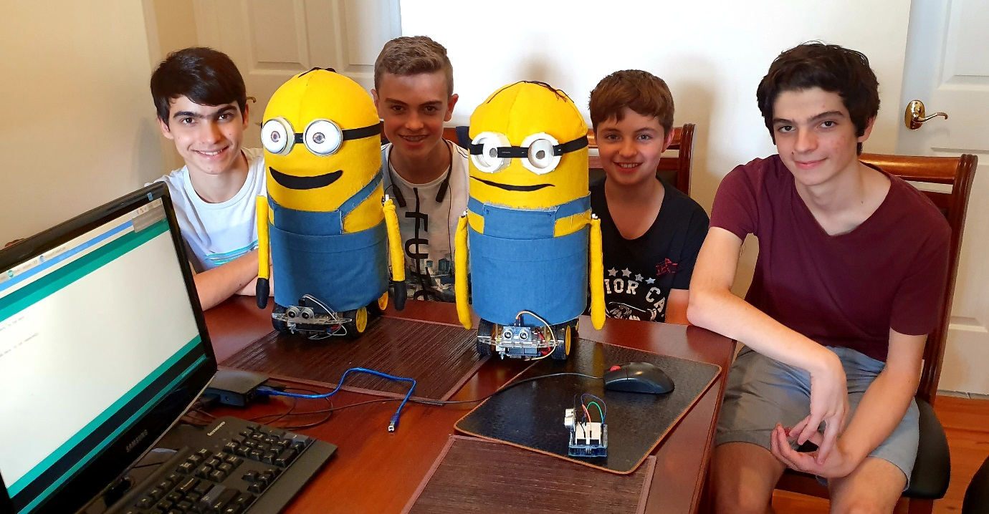

Team: Robot Makers

MeridianTechnoLab

Table of Contents

Project Overview 3

Roles of team members 3

Platform 3

Evolution of the Minion robot 4

First version 4

Second version 5

Third version 6

Minion robot 7

Robot design 7

Construction 7

Step 1. Preparing the platform 7

Step 2. Connecting the power 12

Step 3. Connecting motors 13

Step 4. Connecting the body 14

Step 5. Connecting servo motors (hands) 15

Step 6. Decorating 17

Hardware and Software 22

DC motors control 22

Servo motor control 25

Ultrasonic sensor 27

433MHz radio transmitter and receiver 29

What parts of the project were the hardest? 31

The innovative parts of the robot 31

Credits 31

What’s next 31

Conclusion 32

Appendix 1. Source code of the Minion 33

# Project Overview

We needed to design a performance including a robot, which is appealing and realistic to make. We decided to make a performance, based on despicable me, as we really like the funny minions. For music we chose happy because it is an upbeat song, which suits the style of our performance. We decided to use an EV3 platform, however we found out that it was too slow and couldn't keep up with our fast-paced song. Therefore, we needed to find a platform which can support motors that are fast enough to keep up with our song.

We decided to use Arduino because we already knew how to use and program it. We already conducted projects with DC motors, the ultrasonic sensor and we were going to experiment with bluetooth/radio communication. All of which we will need in our project, as well as the Arduino software.

Then we had to create several steps of the project:

* Build the base
* Solder the wires together
* Connect the motors, power and Arduino
* The framework to hold up the minion
* Decorating the minion
* Programming

We wanted the robot to be the right size/easy to see (Not so small that it's hard to see), to have an entertaining/eye catching performance as well as to have a good looking robot.

To create our project we needed to learn how to solder, use a drill, program servo motors as well as the motor controller. Resources we needed for project:

* Strong and long-lasting batteries,
* Materials for the minion (fabric, metal for the framework, cotton buds and a polyester ball)
* Motor controller

We initially thought the project would take us 4 hours. However 6 months (approximately 72 hours) of work in, we have finished one of the two planned robots.

## Roles of team members

Both of us (Michael and Daniel) took the roles of designers, builders and programmers to create the project. Both of us worked on all aspects of the project. However, if one of us was away, the other would work for both of us. Then when we met again we would collaborate and discuss what was done previously.

## Platform

We decided to use Arduino because we already knew how to use and program it. It allows control of fast DC motors and servo motors. We need DC motors, a motor controller, Li-ion batteries, an ultrasonic sensor and a radio module for robot to robot communication.

# Evolution of the Minion robot

## First version

For the first version, we decided to use a 4 wheel drive platform controlled by an Arduino and we made it move to the music happy, also we designed some complex moves for the robot minion. The robot’s test drive was successful. Then we decided to make the robots body from cotton buds which was supported by aluminium frame. However, the robot was too tall and too heavy, so it was constantly falling down when the robot was braking or turning.

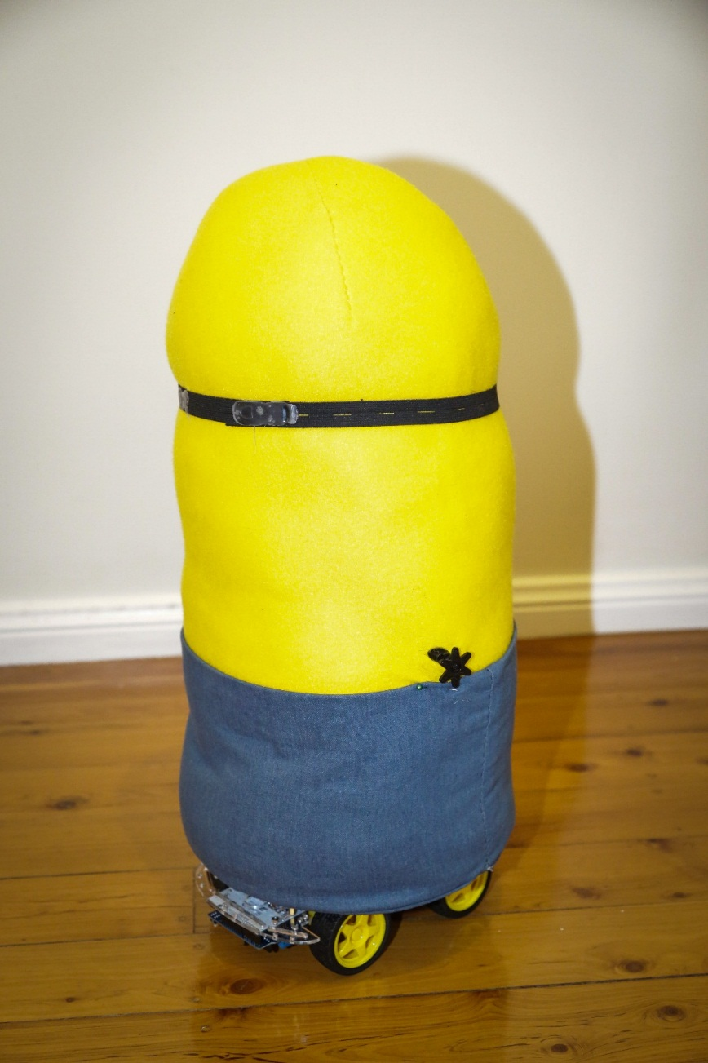

## Second version

Then we decided to use a bigger and heavier aluminium base. We drilled holes, installed motors, controllers, batteries and prepared the robot for the second test. The robot moved too slow because the motors couldn’t handle the weight of the robot.

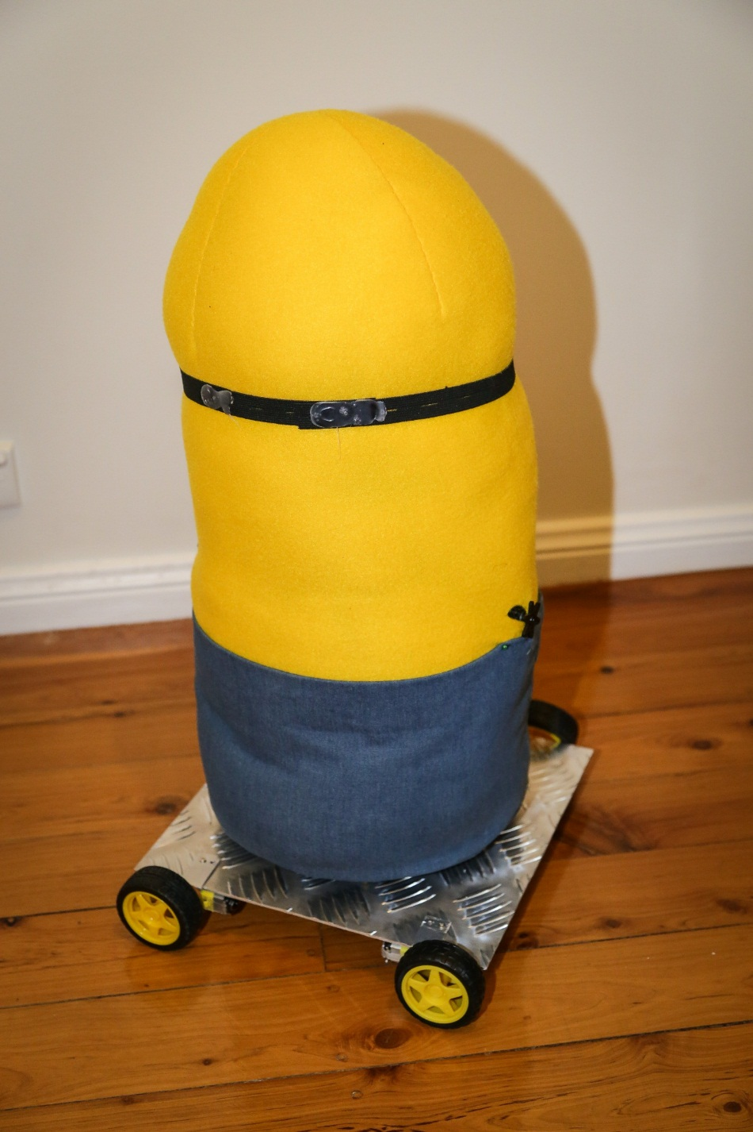

## Third version

For the third version, we used more powerful motors, doubled the power supply and we used an acrylic base. When we started the robot, it was fast but after each turn it was getting slower and slower. We noticed that the motor controller was overheating and couldn’t handle high current for powerful motors.

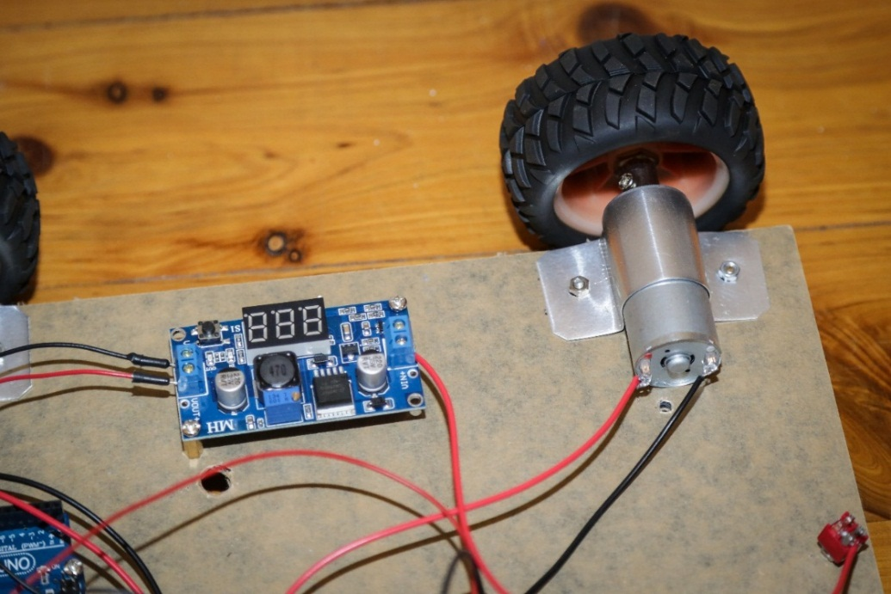

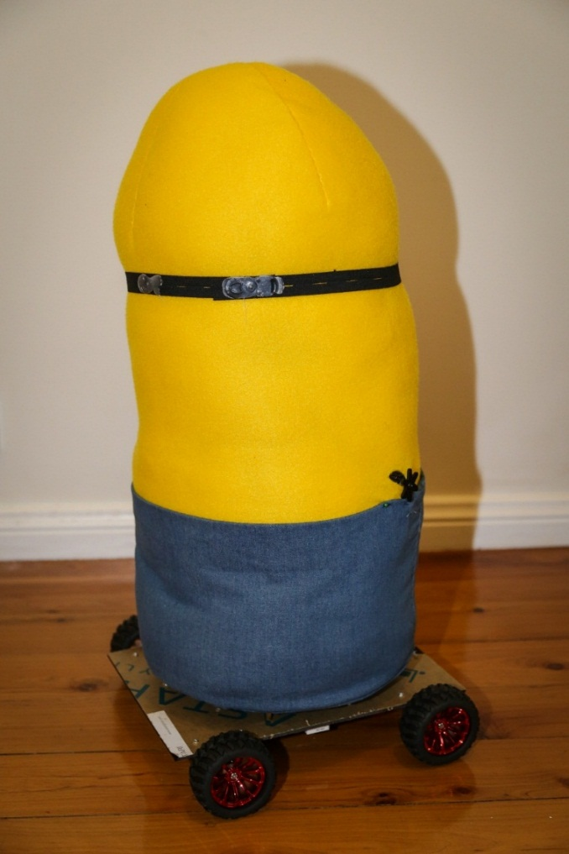

# Minion robot

## Robot design

The arrangement of robot parts: Minion of top of the base so that it can be seen, the controller and electronics on the bottom of the base so that they aren't seen and don't interfere with any moving parts, we put the batteries in the middle so that they move the robot’s centre of gravity there. The DC motors are located near each of the four corners of the base. These motors control the wheel speed and direction.

We also have two servo motors on opposite sides which are used to control the hands. These can turn 180 degrees. We use the ultrasonic sensor which is located at the front of the robot's base to activate the robot. Furthermore, our intention is to use the ultrasonic sensor to detect any object or person and stop the robot from colliding with it. All components are well secured, the wires are soldered, the minion has a frame screwed to the base and the rest of the parts are also screwed into place on the base.

## Construction

### Step 1. Preparing the platform

The cover was removed from the acrylic base and the wheels were slotted onto the motors.

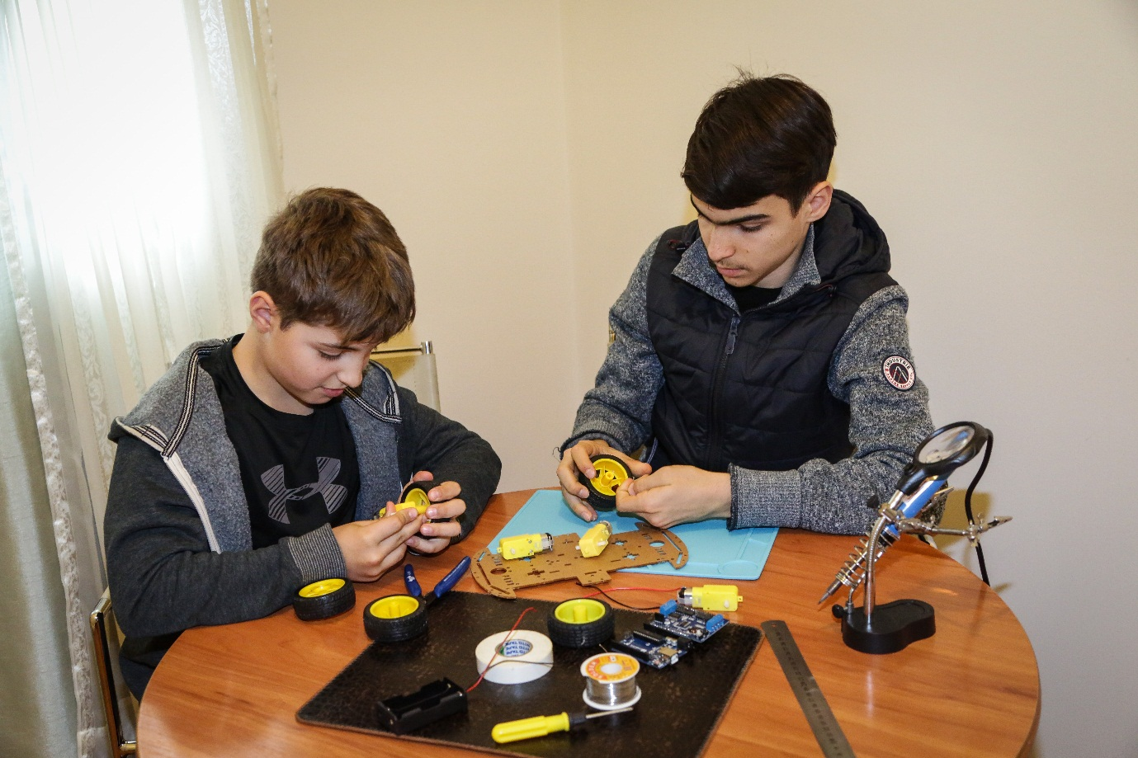

We soldered wires to the motors.

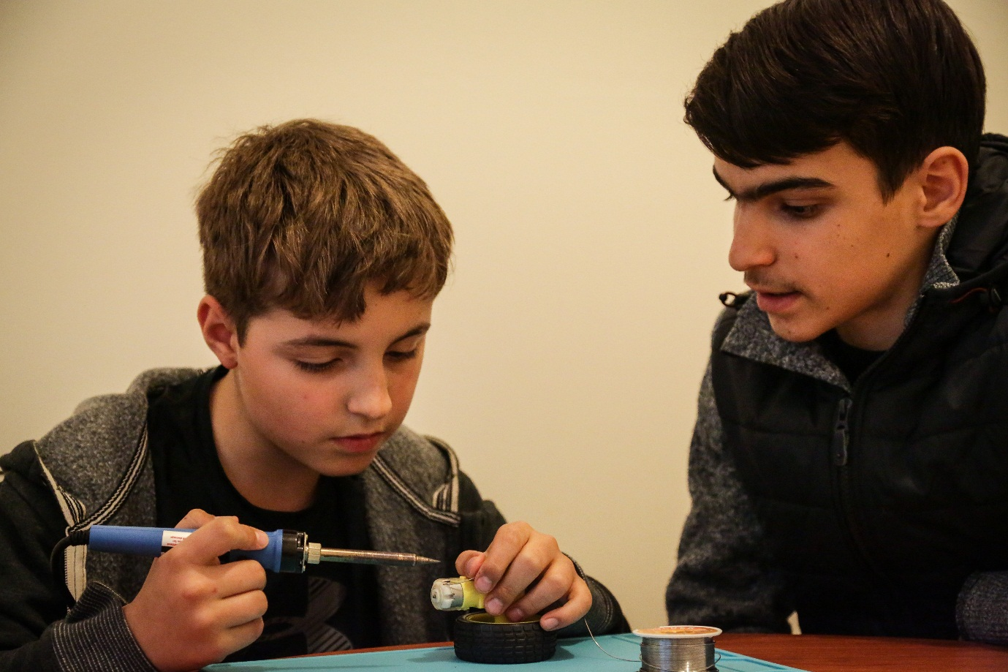

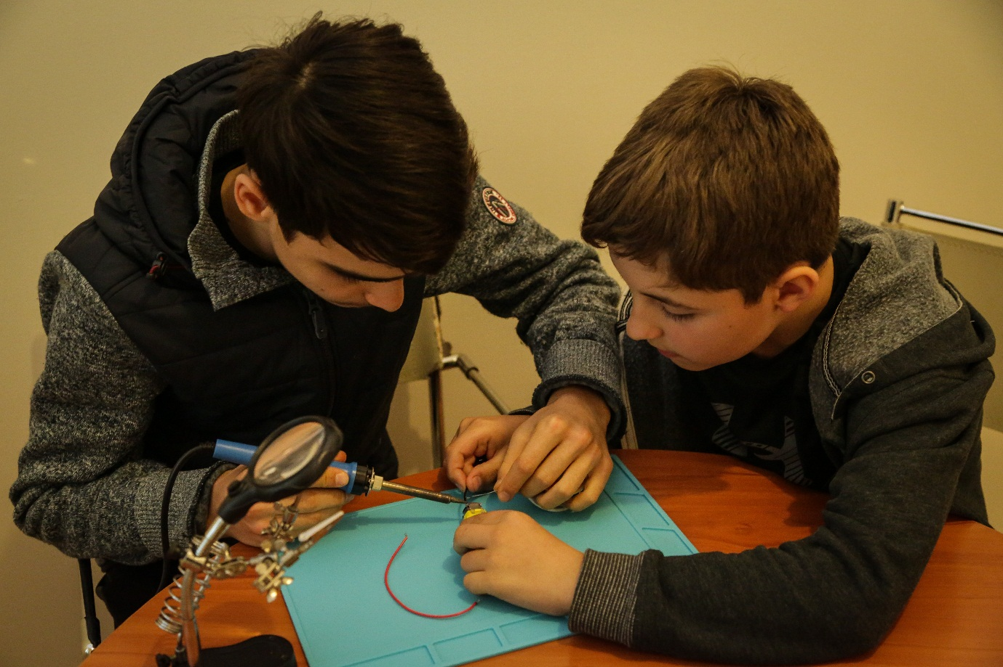

After marking out where we wanted to place the Arduino and batteries, we drilled holes in the platform so that later we can screw them together.

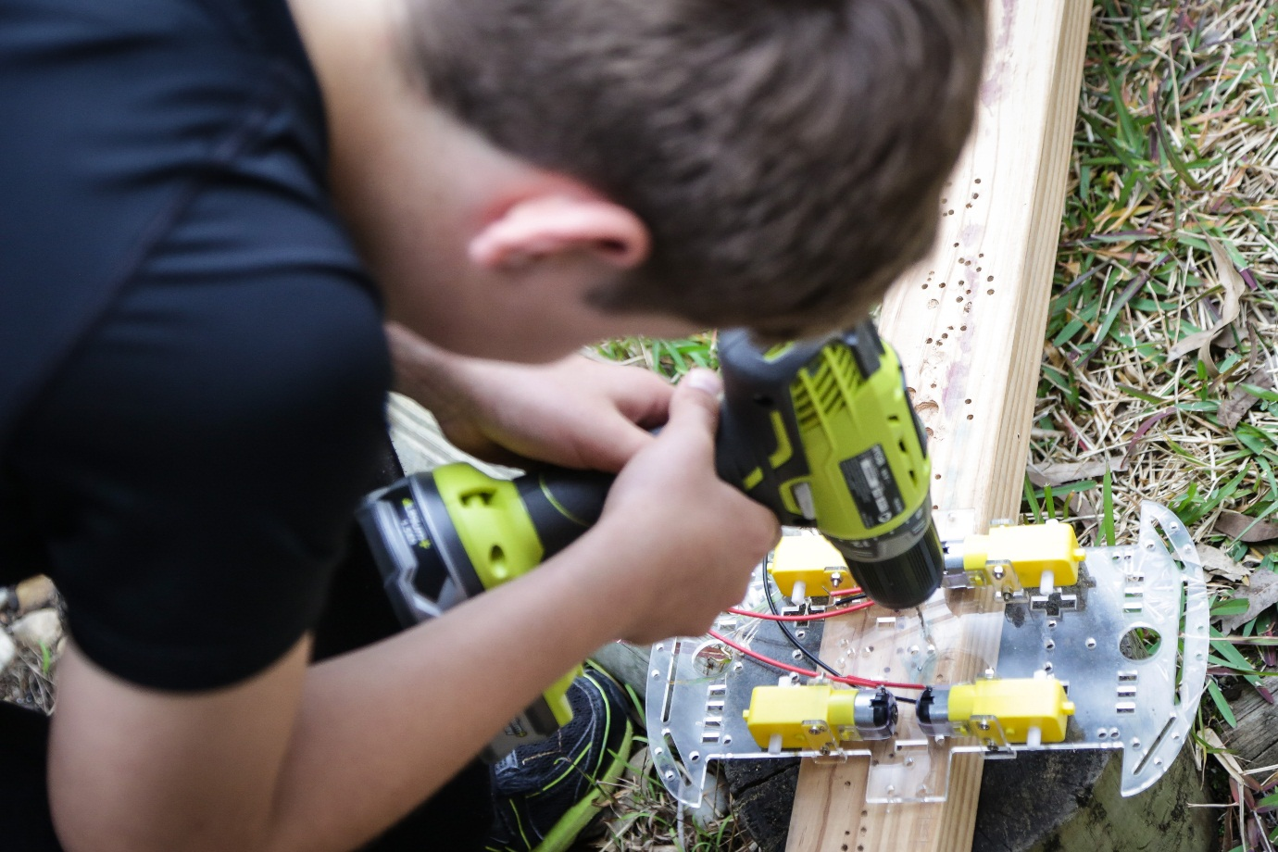

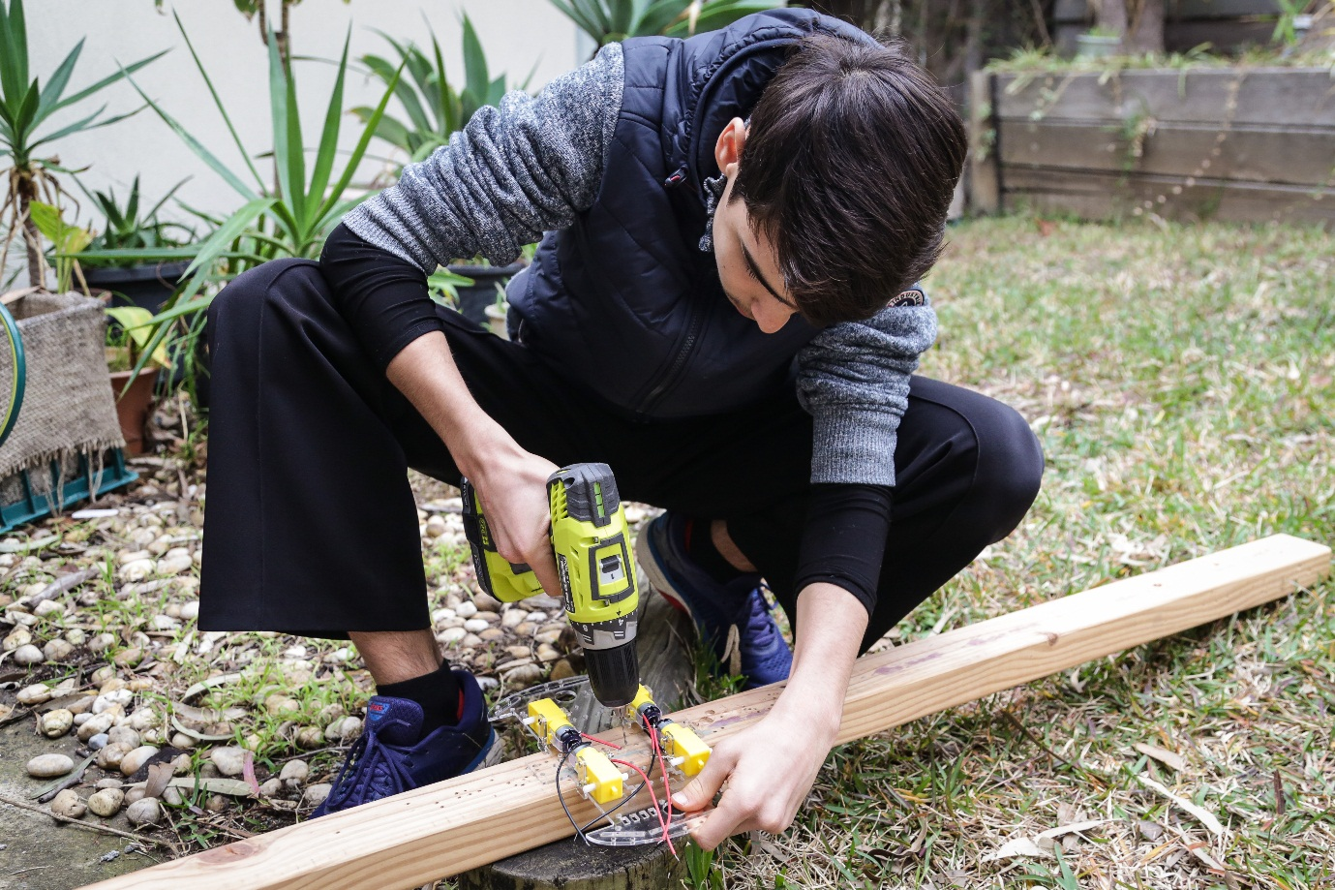

We screwed the battery holder in the middle of the platform.

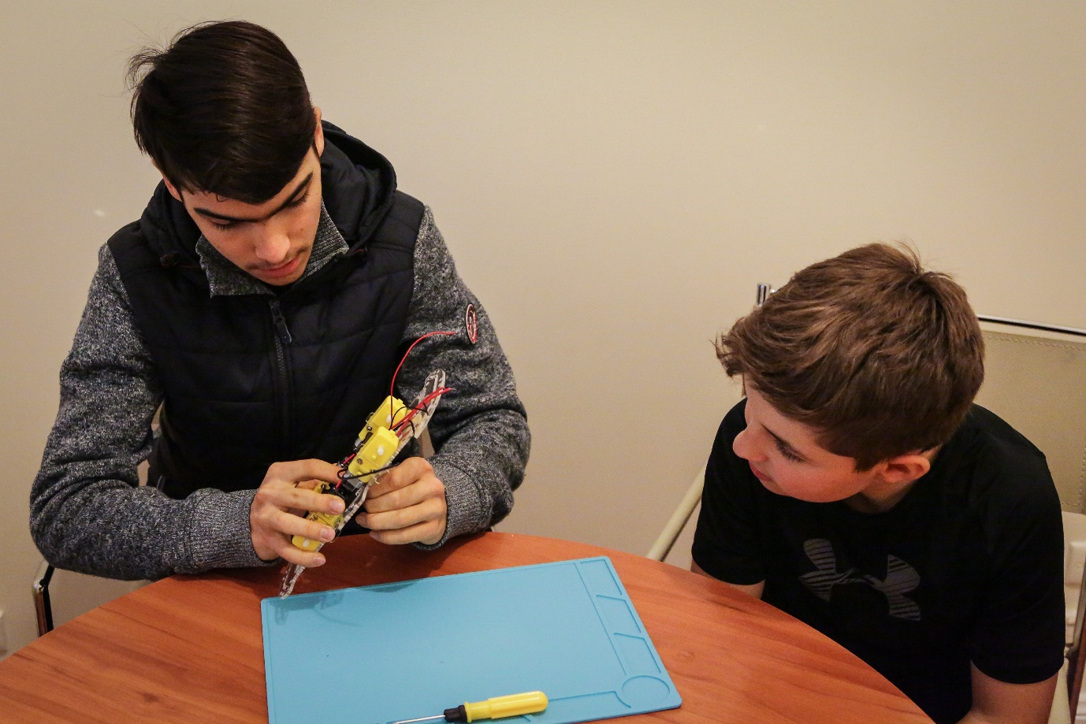

We also placed the Arduino microcontroller in the front of the platform.

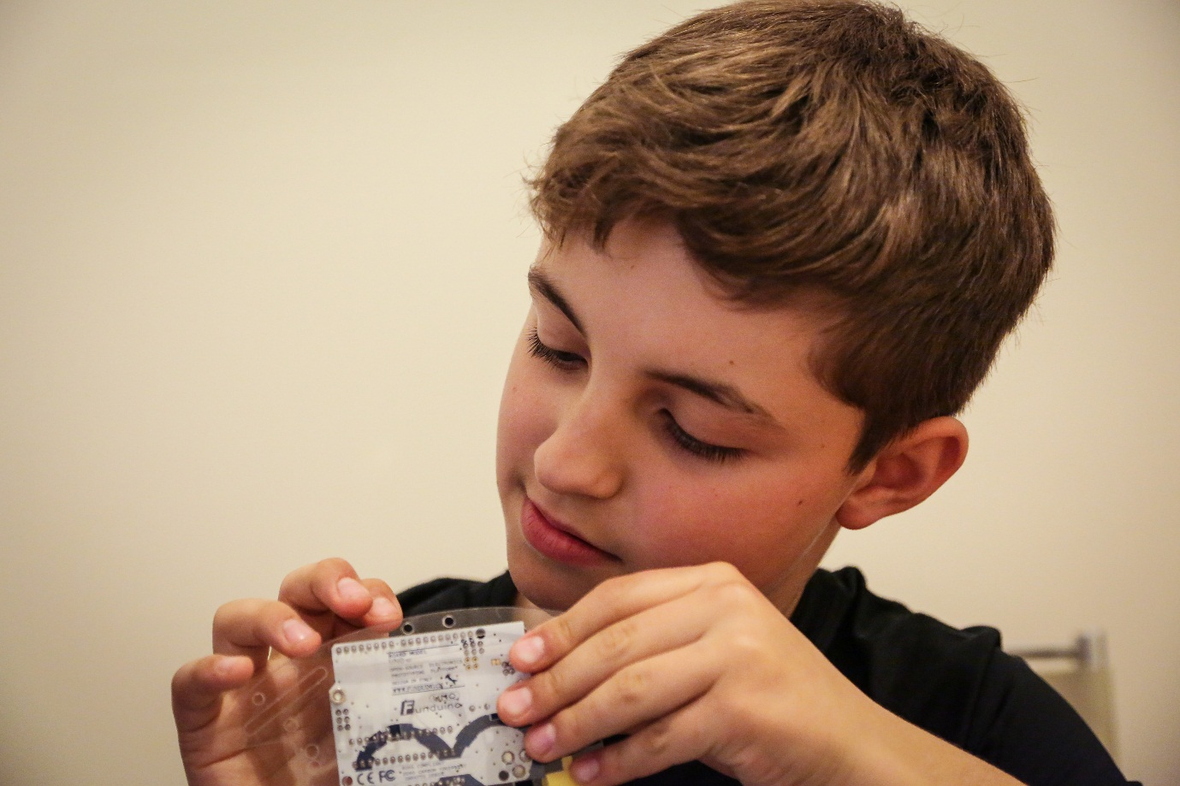

All components are installed and we are ready to connect wires and start testing the robot.

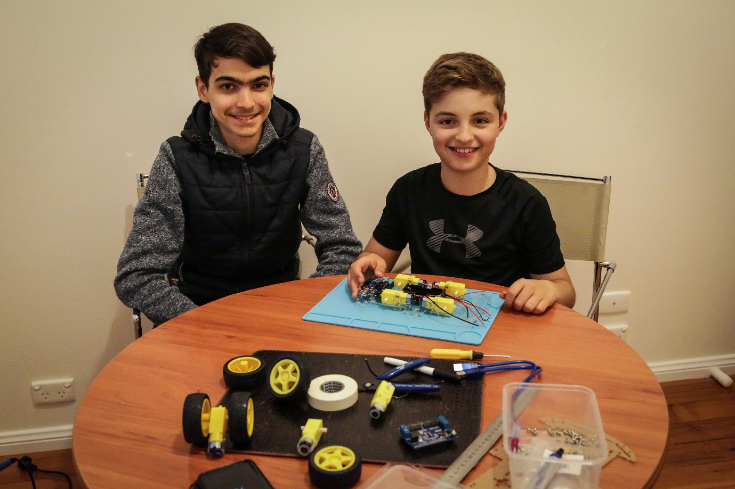

### Step 2. Connecting the power

We connected wires from the batteries to the motor controller (black to ground and red to power).

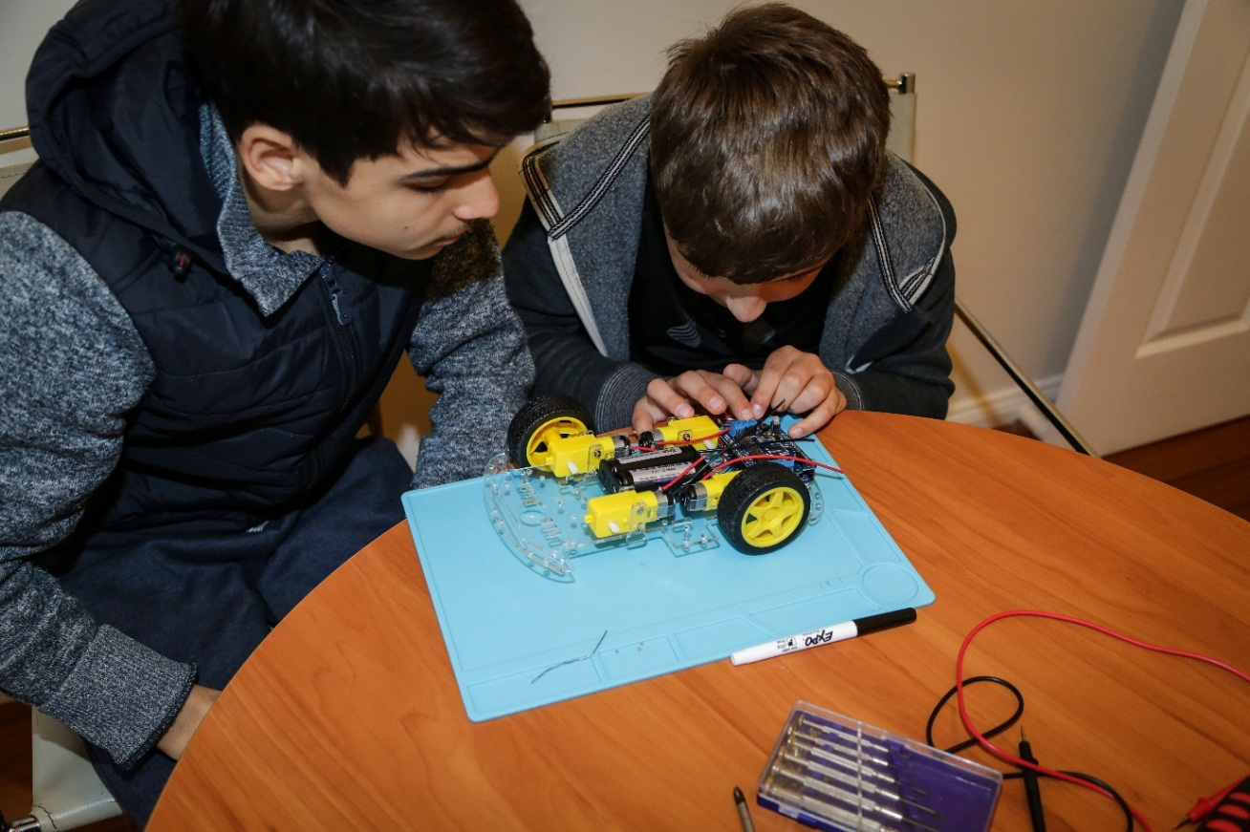

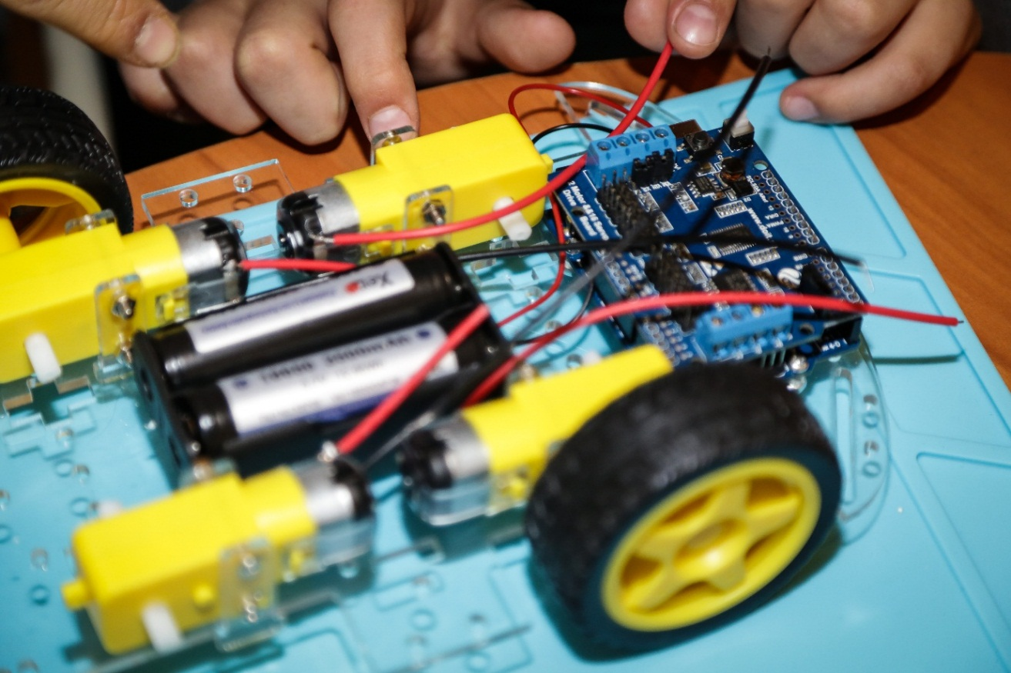

### Step 3. Connecting motors

Using a multimeter we made sure that the circuit was working correctly and the batteries were providing power to the motor controller.

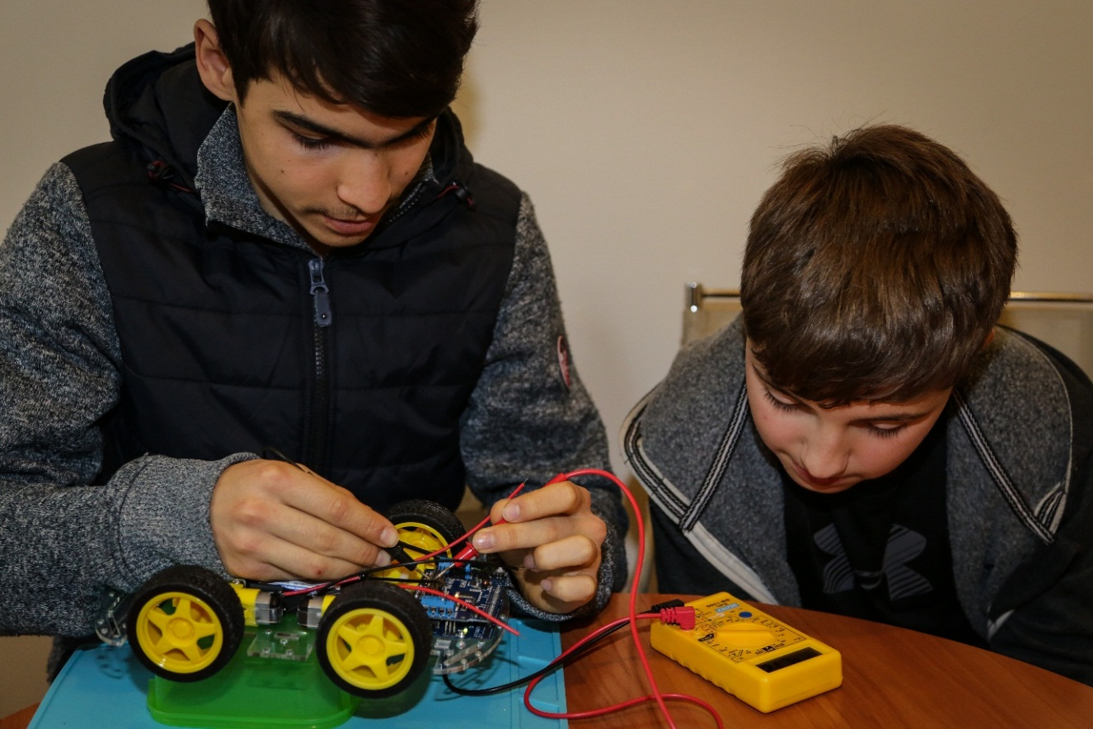

First, we connected the front motors to make sure they were both spinning in the right direction (which one wasn’t and therefore we had to switch the positions of its wires). Then we connected the back motors to the front ones on the same side, so that they work in unison.

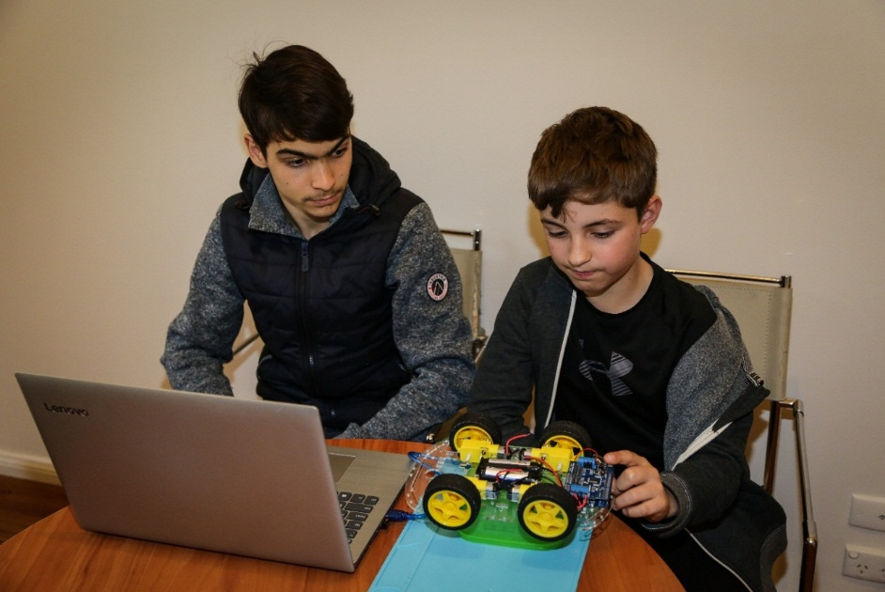

### Step 4. Connecting the body

We decided to use a piggy bank made from tin as a body. It’s the perfect size and is light. For the top of the head we will be using a styrofoam sphere.

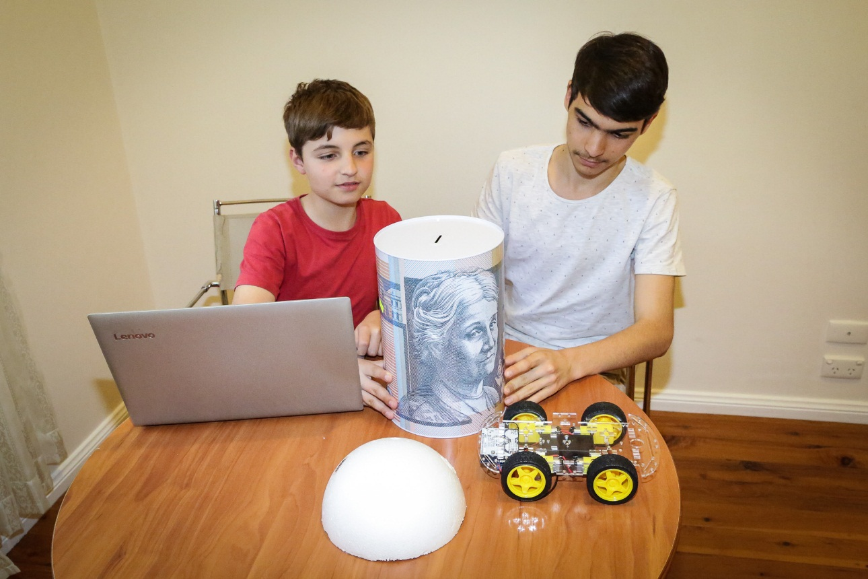

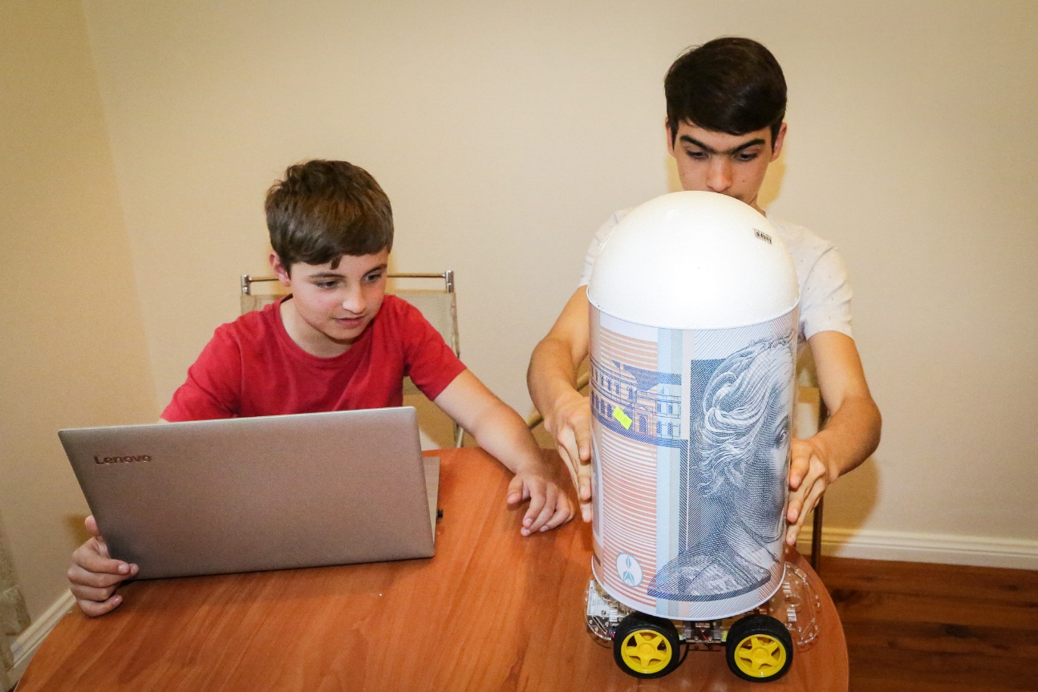

### Step 5. Connecting servo motors (hands)

We cut holes in the minion’s body and glued 2 servo motors in them, to control the hands.

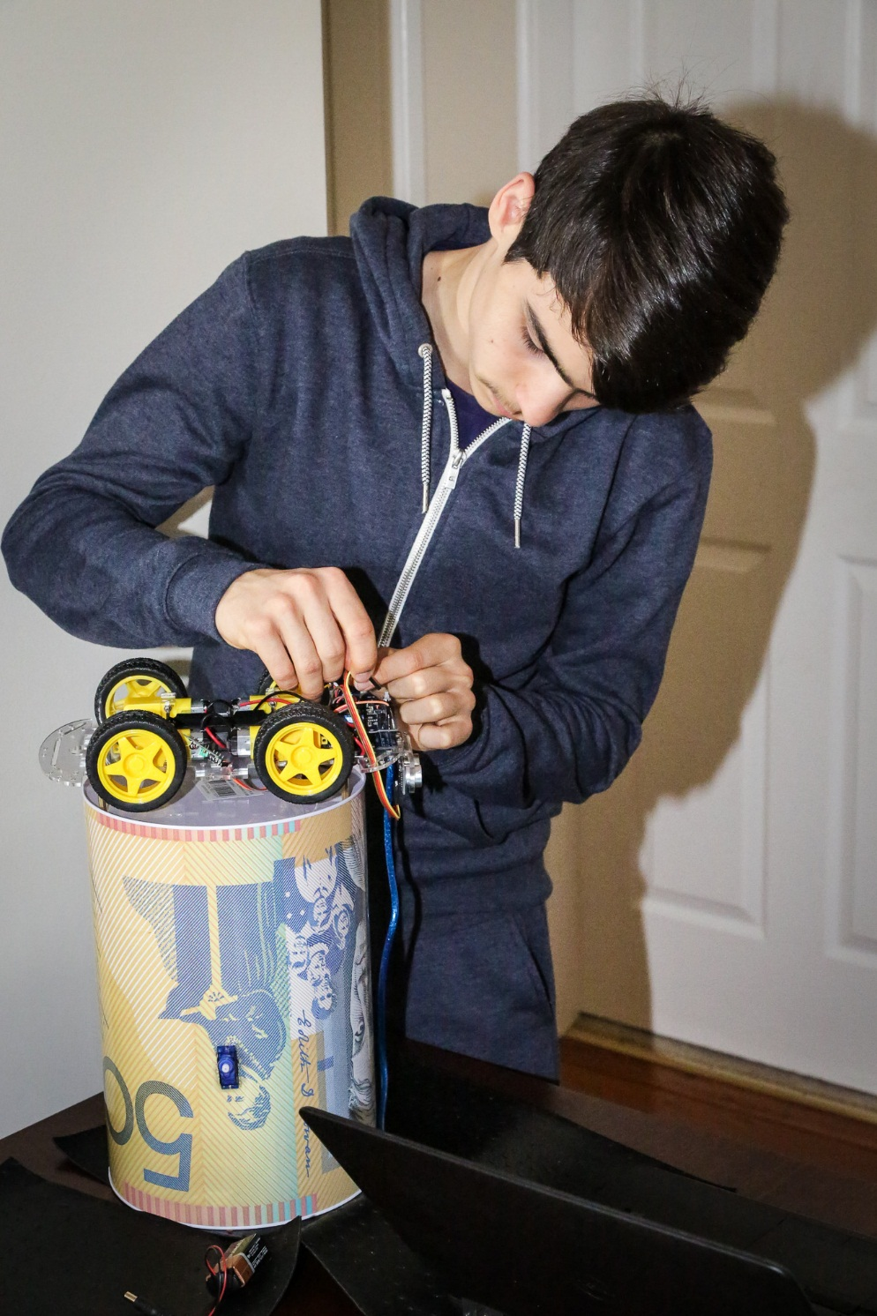

We connected wires from the servo motors to ports 0 and 1 on the motor controller.

We used chopsticks to support the hands. Then we secured servo connectors to them using string, so that the servo motors can move them.

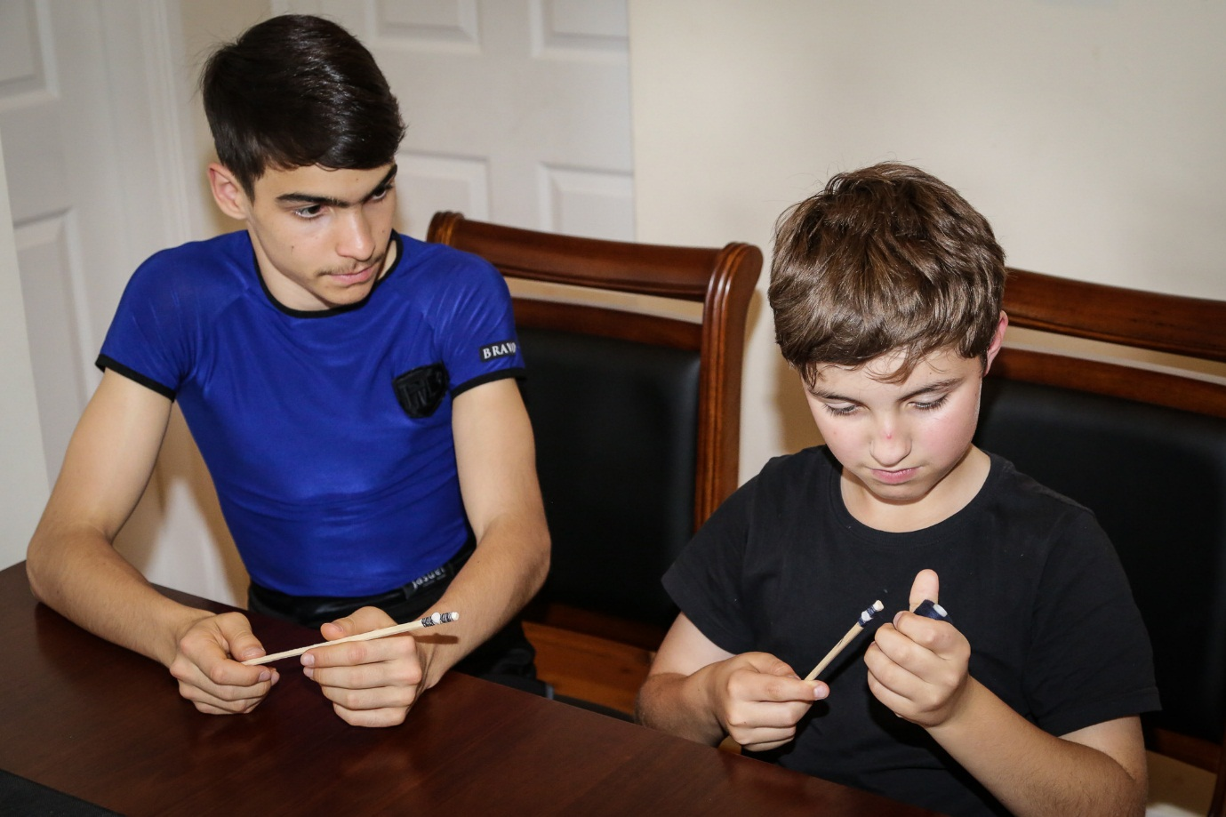

### Step 6. Decorating

The circumference of the robot was measured so that we knew where to cut the fabric.

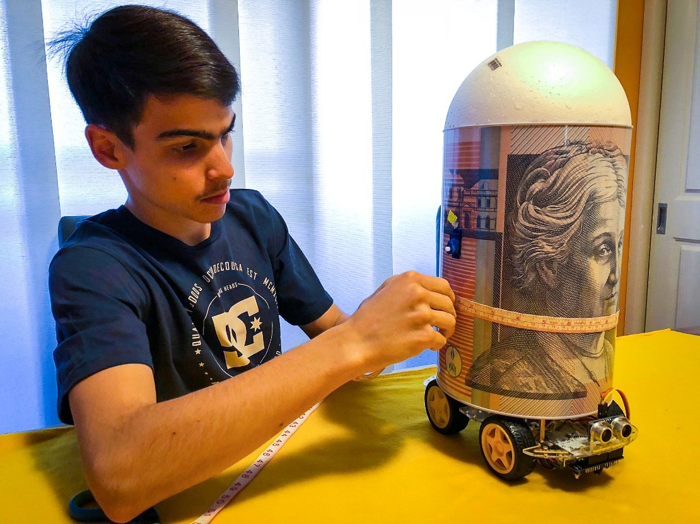

Lines were marked on the fabric according to the measurements i.e. Since the circumference was 30cm, a distance 30cm from the side of the fabric was marked.

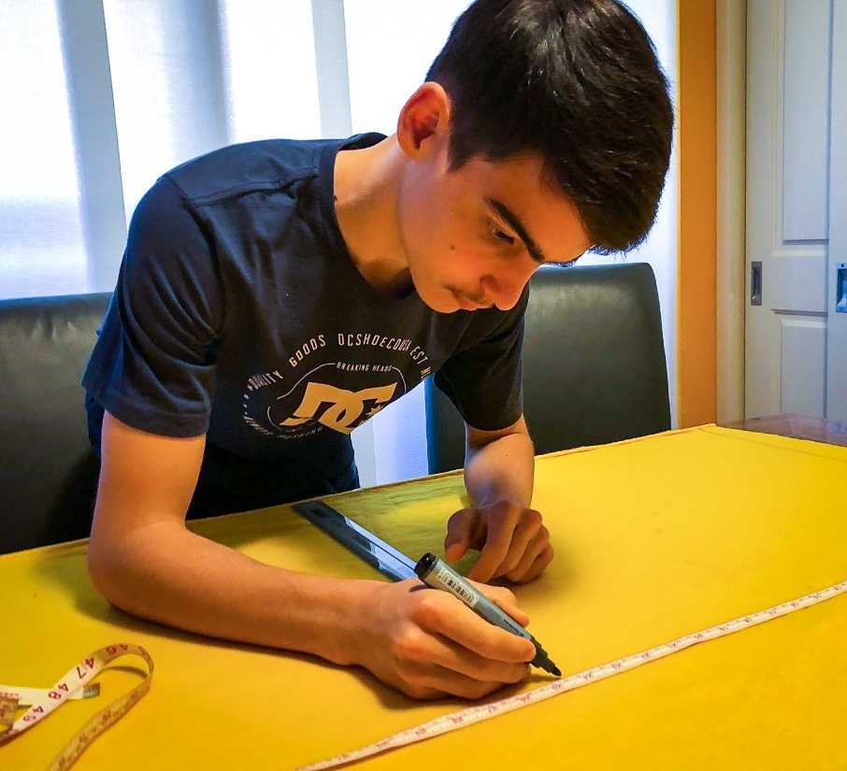

After the fabric was put on the minion inside out. The overlapping parts were hand-sewn together.

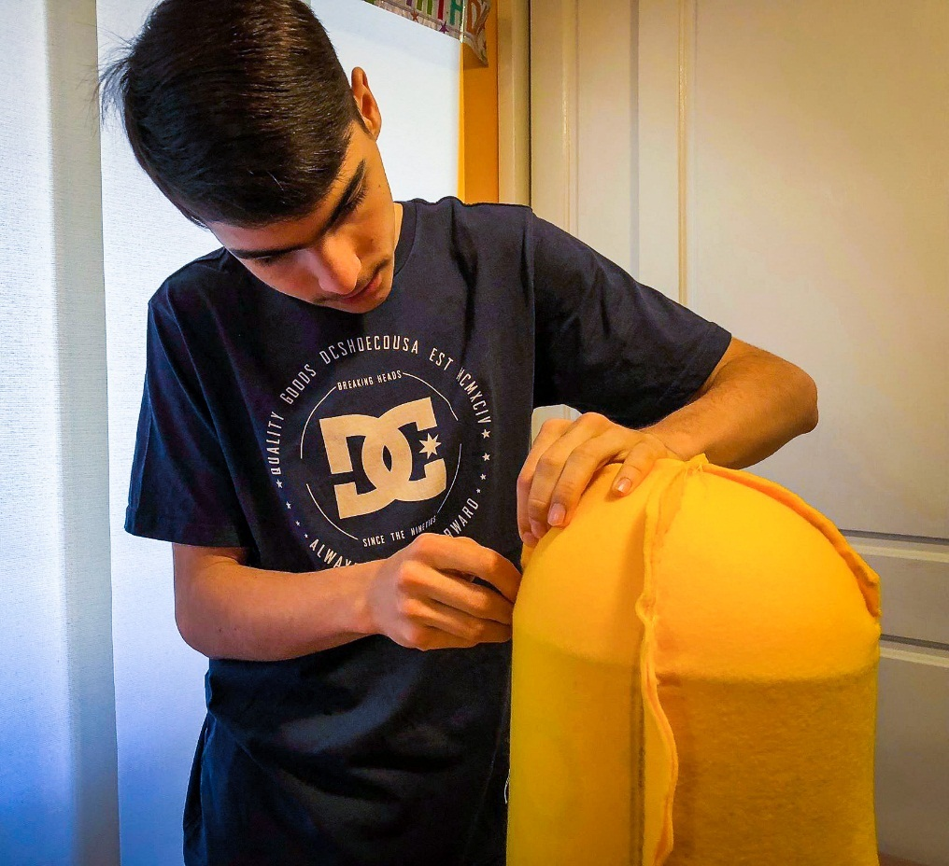

he same was done to the trousers (marking and cutting) however, instead of sewing the fabric together. We ironed the folds so that they stayed together and used pins to keep them around the minion.

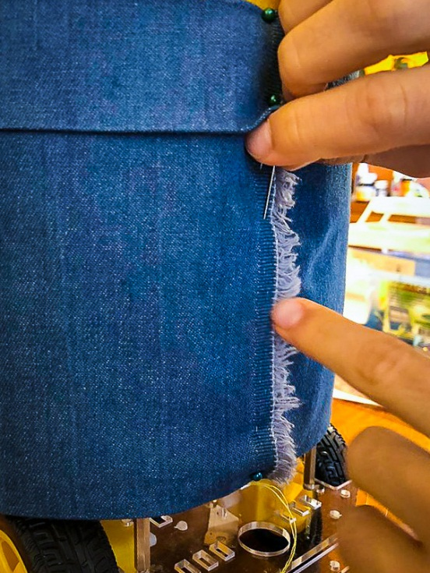

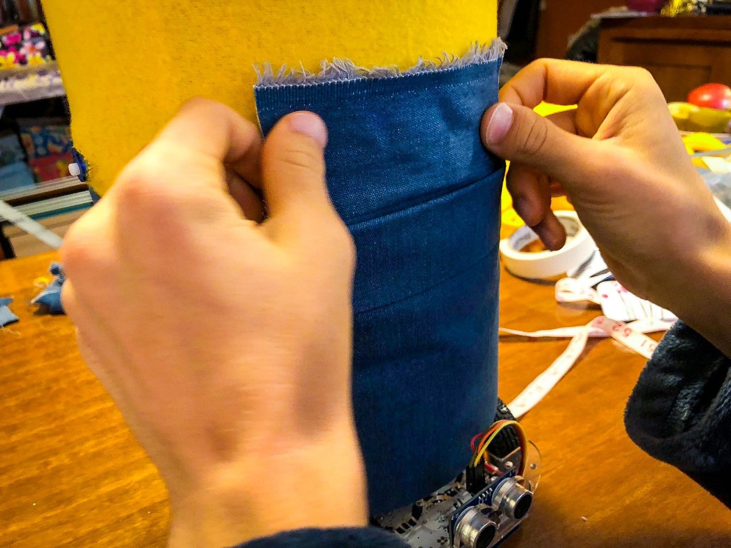A piece of fabric was tucked into the minion’s pants.

String was sewed onto the minion’s head as hair.

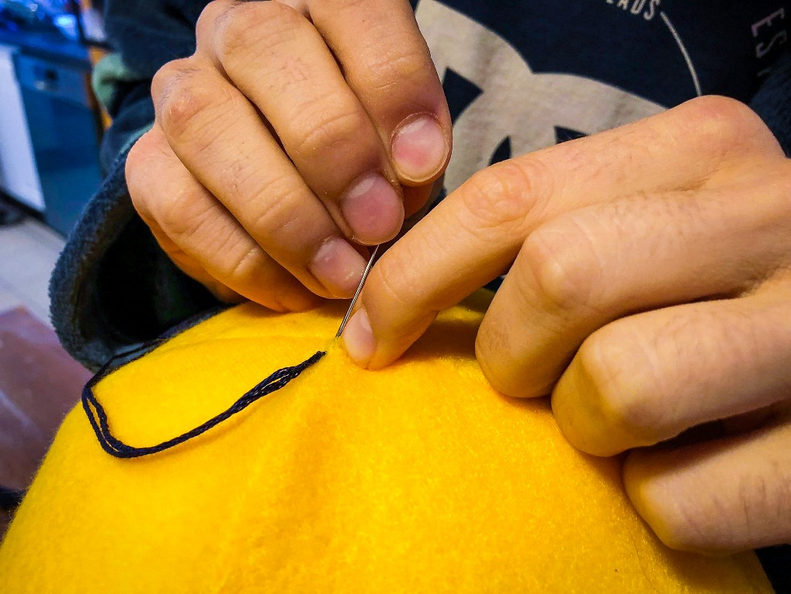

After marking and cutting the fabric for the hands, the overlap was sewn together.

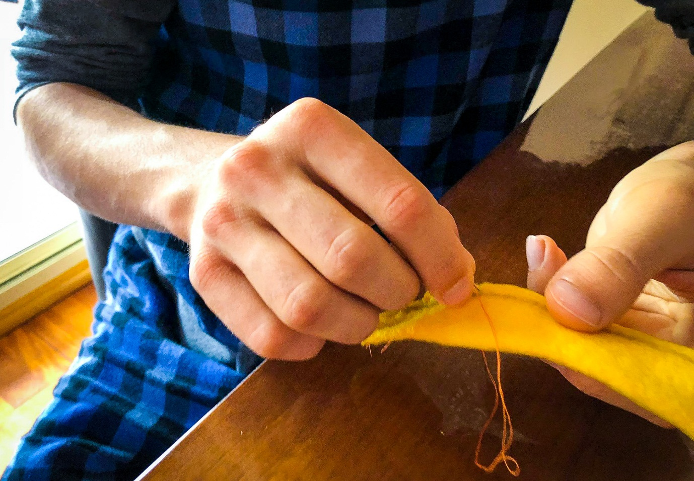

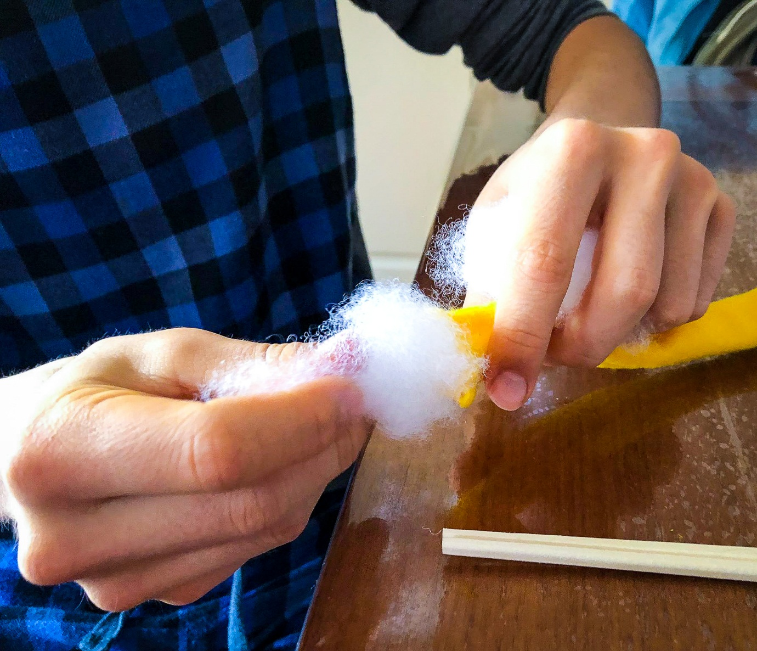

The arm was turned inside out and stuffed with polyester.

## Hardware and Software

We decided to use Arduino because we already knew how to use and program it. We have already completed projects with motors and ultrasonic sensors and we wanted to learn more about servo motors and radio communication.

Components we used to build the minion robot:

|  |  |  |
| --- | --- | --- |
| **N** | **Name** | **Qty** |
| 1 | Arduino UNO | 1 |
| 2 | 2 Motor and 16 Servo Drive Board | 1 |
| 3 | HC-SR04 Ultrasonic Sensor | 1 |
| 4 | Tower Pro SG90 Servo Motor | 2 |
| 5 | TT DC Motor | 4 |
| 6 | Wheel | 4 |
| 7 | 433 MHz RF Transmitter and Receiver | 1 |
| 8 | Li-ion 18650 Battery | 2 |
| 9 | Li-ion 18650 Battery Holder | 1 |
| 10 | Tin Can (Body) | 1 |
| 11 | styrofoam Ball (Top of the head) | 1 |

### DC motors control

We used a DC motor controller which has 2 ports which can support two DC motors. There are four pins which are used to control them, these are DIR A which controls the direction of one motor and PWM A which controls the speed of the same motor. The other two pins do the same for the second motor. We created functions to control these motors so that we only have to type in the speed and direction. This also gives us flexibility if we decide to change the function, as we will only have to change one piece of code instead of lines and lines of it.

// Move robot forward

void RobotMoveForward(int iSpeed, int iTime) {

digitalWrite(MotorDirA, HIGH);

analogWrite(MotorPWMA, iSpeed);

digitalWrite(MotorDirB, HIGH);

analogWrite(MotorPWMB, iSpeed);

delay(iTime);

}

// Move robot back

void RobotMoveBack(int iSpeed, int iTime) {

digitalWrite(MotorDirA, LOW);

analogWrite(MotorPWMA, iSpeed);

digitalWrite(MotorDirB, LOW);

analogWrite(MotorPWMB, iSpeed);

delay(iTime);

}

// Turn robot Left

void RobotTurnLeft(int iSpeed, int iTime) {

digitalWrite(MotorDirA, HIGH);

analogWrite(MotorPWMA, iSpeed);

digitalWrite(MotorDirB, LOW);

analogWrite(MotorPWMB, iSpeed);

delay(iTime);

}

// Turn robot left degrees

void RobotTurnLeftDegrees(int iDegrees) {

digitalWrite(MotorDirA, HIGH);

analogWrite(MotorPWMA, 200);

digitalWrite(MotorDirB, LOW);

analogWrite(MotorPWMB, 200);

delay(K_Left * iDegrees);

}

// Turn robot right

void RobotTurnRight(int iSpeed, int iTime) {

digitalWrite(MotorDirA, LOW);

analogWrite(MotorPWMA, iSpeed);

digitalWrite(MotorDirB, HIGH);

analogWrite(MotorPWMB, iSpeed);

delay(iTime);

}

// Turn robot right degrees

void RobotTurnRightDegrees(int iDegrees) {

digitalWrite(MotorDirA, LOW);

analogWrite(MotorPWMA, 200);

digitalWrite(MotorDirB, HIGH);

analogWrite(MotorPWMB, 200);

delay(K_Right * iDegrees);

}

// Smooth turn robot

void RobotSmoothTurn(int iSpeedA, int iSpeedB, int iTime) {

digitalWrite(MotorDirA, HIGH);

analogWrite(MotorPWMA, iSpeedA);

digitalWrite(MotorDirB, HIGH);

analogWrite(MotorPWMB, iSpeedB);

delay(iTime);

}

// Stop robot

void RobotStop(int iTime) {

analogWrite(MotorPWMA, 0);

analogWrite(MotorPWMB, 0);

delay(iTime);

}

### Servo motor control

We used 2 TowerPro SG90 servo motors to control robot’s hands. Motor controller allows control up to 16 servo motors. We only used ports 0 and 1.

We only used three positions for the hands – up, forward and down. Therefore, we decided to create functions to move the hands to these positions:

// Left hand up

void LeftHandUp() {

pwm.setPWM(1, 0, 150);

}

// Left hand down

void LeftHandDown() {

pwm.setPWM(1, 0, 600);

}

// Left hand forward

void LeftHandForward() {

pwm.setPWM(1, 0, 320);

}

// Right hand up

void RightHandUp() {

pwm.setPWM(0, 0, 600);

}

// Right hand down

void RightHandDown() {

pwm.setPWM(0, 0, 150);

}

// Right hand forward

void RightHandForward() {

pwm.setPWM(0, 0, 350);

}

// Both hands up

void HandsUp() {

LeftHandUp();

RightHandUp();

}

// Both hands down

void HandsDown() {

LeftHandDown();

RightHandDown();

}

// Both hands forward

void HandsForward() {

LeftHandForward();

RightHandForward();

}

### Ultrasonic sensor

We are using the ultrasonic sensor to start our program when it sees our hand approximately 5-40 cm away from it. We also want to use it to stop any collision by not allowing the robot to move forward when it sees an object in front of it, which will protect the robot and humans.

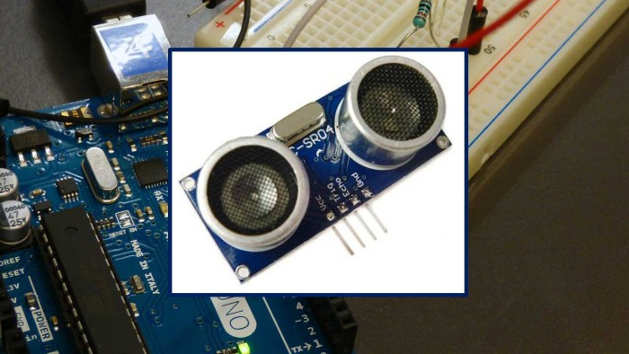

The ultrasonic sensor calculates distance by sending a signal with its transmitter (trigger pin) in the form of a high-frequency sound. When this hits an object, it’s reflected and comes back to be received by the receiver (echo pin).

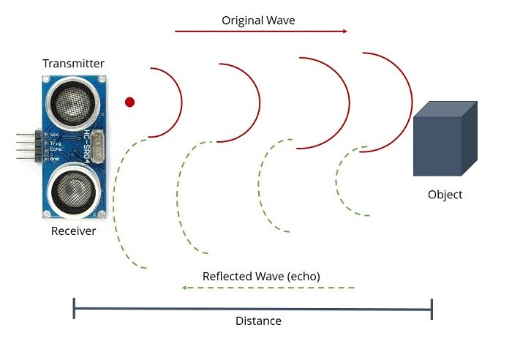

Then, the time between sending and receiving the signal is used to calculate the distance between the sensor/object. Since we know the speed of sound, it means that the processor can use the following formula to calculate the distance. Distance = Speed x Time.

We created the function “UltraSonicActivation” for the first robot to wait until it sees our hands:

// Ultrasonic activation

void UltraSonicActivation() {

int uS = sonar.ping_cm();

delay(50);

while ((uS == 0) || (uS > 30)) {

uS = sonar.ping_cm();

Serial.print("Activation: ");

Serial.print(uS);

Serial.println("cm");

delay(50);

}

Serial.println("US: Start dancing");

}

### 433MHz radio transmitter and receiver

We decided to use a 433MHz radio transmitter and receiver for robot to robot communication. When the first robot is activated using the ultrasonic sensor it will send another robot the “start dancing” command using its 433MHz transmitter. We also noticed that one robot is faster than the other, so we decided to use radio signals to synchronise both robots.

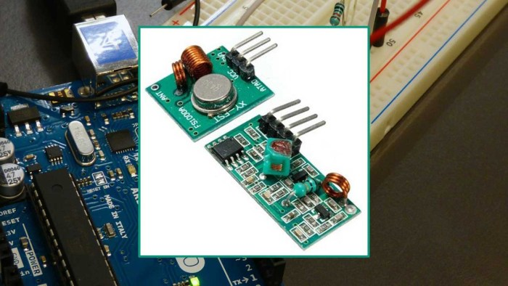

We created the “SendStart” function in the program for the first minion to send the command to the second robot:

// Tell another minion to start dancing

void SendStart() {

const char *msg = "start";

radio.send((uint8_t *)msg, strlen(msg));

radio.waitPacketSent();

delay(50);

Serial.println("RF: Sent start");

}

We also created the “RadioActivation” function in the program for the second Minion to wait until the Start command received:

// Radio activation

void RadioActivation() {

uint8_t buf[5];

uint8_t buflen = 5;

String st = " ";

while (st.substring(0, 5) != "start") {

if (radio.recv(buf, &buflen))

{

st = (char*)buf;

}

delay(50);

}

Serial.println("RF: Start dancing");

}

## What parts of the project were the hardest?

The hardest part of the project was making sure the robot could still move and dance. When we started the program after putting the body on the first version, for the first time, it simply kept falling backwards.

Hence, we decided to make a lighter body, make the robot’s centre of gravity as close the middle and low as possible (by placing the heaviest object such as batteries there).

We also had to change the robot’s routine as it couldn’t cope with the turns. If we could start again, we would definitely make the robot first and then design the routine as we had to throw the first version out because of physical limitations.

In the future we plan to use a gyro sensor to calculate how far the robot has turned, as well as to be able to control the arms (Putting a gyro sensor along with a transmitter into our gloves, allowing the robot to mirror our arm movements using a receiver).

## The innovative parts of the robot

We built exactly what we wanted: A fast robot, with an ultrasonic sensor for activation and to prevent collision and radio communication.

# Credits

Both of us (Michael and Daniel) designed, built and programmed to create the robot. Both of us worked on each step of the project. However, if one of us was away, the other would work for both of us. Then when we met again we would collaborate and discuss what was done previously.

# What’s next

We would like to make a few changes in the future:

1. Using “parallel processing” to measure distance using an ultrasonic sensor and to stop the robot if it sees objects in front while it’s moving.
2. Use a gyro sensor to control the robot’s turns.
3. Use gyro sensors in our gloves to manually control robot’s hands.

# Conclusion

It took about 8 months to experiment and build two minions and program them.

During this time we have learnt a lot:

* how to design robots and manage projects;
* how to solder, drill and cut acrylic and aluminium sheets;
* how to calibrate and control DC and servo motors
* how to use radio transmitter and receiver
* problem solving and debugging

It was lots of fun although at times frustrating, but we are very happy with our minion robots!

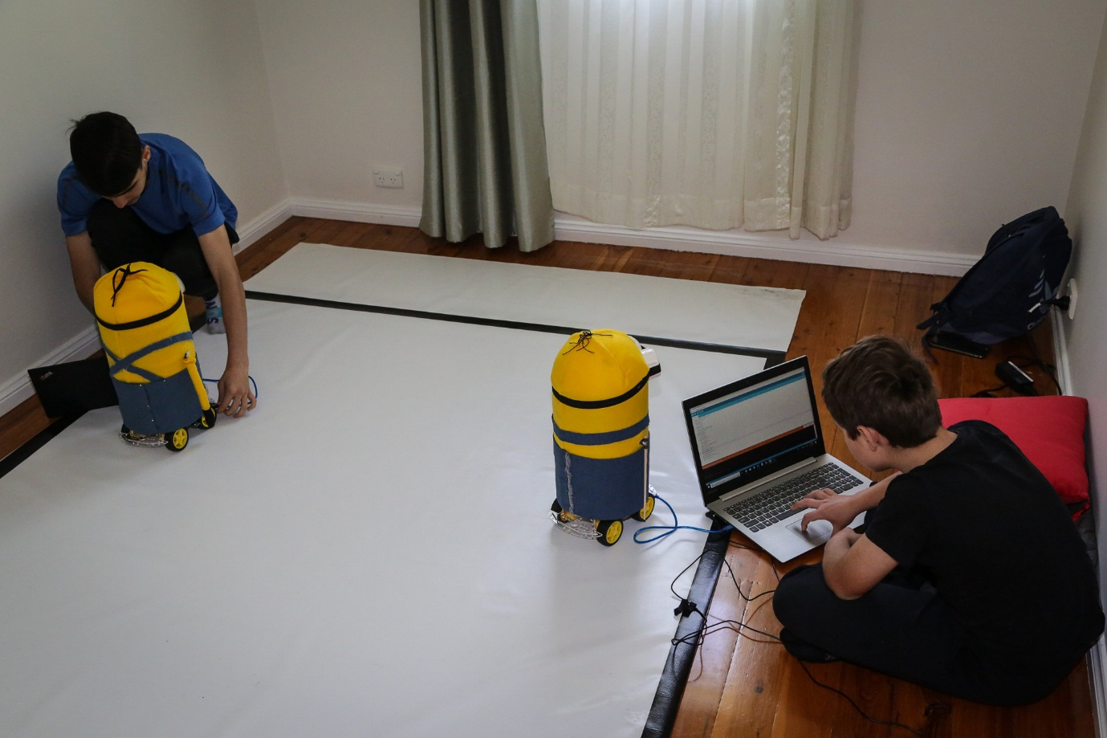

# Appendix 1. Source code of the Minion

///////////////////////////////////////////////////////////////////////////////////////////////////////////////////

//

// Dancing minion 1

// ver. 5.1

// Last updated: 3/10/2018

//

///////////////////////////////////////////////////////////////////////////////////////////////////////////////////

#include <NewPing.h>

#include <ServoDriver.h>

#include <RH_ASK.h>

#include <SPI.h>

// Radio reciever - pin 3, transmitter - pin 4

RH_ASK radio(2000, 3, 4);

// Servo control

ServoDriver pwm = ServoDriver();

// Ultrasonic Sensor

#define TRIGGER_PIN 11

#define ECHO_PIN 12

#define MAX_DISTANCE 200

NewPing sonar(TRIGGER_PIN, ECHO_PIN, MAX_DISTANCE); // UltraSonic sensor - setup of pins and maximum distance

// Motor A

const int MotorDirA = 8;

const int MotorPWMA = 9;

// Motor B

const int MotorDirB = 7;

const int MotorPWMB = 6;

// Turn and move calibration

const float K_Right = 1600 / 180; // Turn right 1 degree, msec

const float K_Left = 1300 / 180; // Turn left 1 degree, msec

const float K_Forward = 1600/ 100; // Move forward 1 cm, msec

const float K_Backwards = 1600 / 100; // Move backwards 1 cm, msec

// Turn calibration

void TurnCalibration() {

HandsDown();

UltraSonicActivation();

delay(1000);

RobotTurnRight(200, 1500);

RobotStop(1000);

RobotTurnLeft(200, 1250);

RobotStop(1000);

}

// Move calibration

void MoveCalibration() {

HandsDown();

UltraSonicActivation();

RobotMoveForwardSpeed(180, 190, 1600);

RobotStop(1000);

RobotMoveBackSpeed(240, 150, 1600);

RobotStop(1000);

}

// Move robot forward

void RobotMoveForwardSpeed(int SpeedLeft, int SpeedRight, int iTime) {

digitalWrite(MotorDirA, HIGH);

analogWrite(MotorPWMA, SpeedLeft);

digitalWrite(MotorDirB, HIGH);

analogWrite(MotorPWMB, SpeedRight);

delay(iTime);

}

// Move robot back

void RobotMoveBackSpeed(int SpeedLeft, int SpeedRight, int iTime) {

digitalWrite(MotorDirA, LOW);

analogWrite(MotorPWMA, SpeedLeft);

digitalWrite(MotorDirB, LOW);

analogWrite(MotorPWMB, SpeedRight);

delay(iTime);

}

// Move robot forward cm

void RobotMoveForwardCM(int iCM) {

RobotMoveForwardSpeed(200, 170, K_Forward * iCM);

}

// Move robot back cm

void RobotMoveBackCM(int iCM) {

RobotMoveBackSpeed(200, 170, K_Backwards * iCM);

}

// Move robot forward

void RobotMoveForward(int iSpeed, int iTime) {

digitalWrite(MotorDirA, HIGH);

analogWrite(MotorPWMA, iSpeed);

digitalWrite(MotorDirB, HIGH);

analogWrite(MotorPWMB, iSpeed);

delay(iTime);

}

// Move robot back

void RobotMoveBack(int iSpeed, int iTime) {

digitalWrite(MotorDirA, LOW);

analogWrite(MotorPWMA, iSpeed);

digitalWrite(MotorDirB, LOW);

analogWrite(MotorPWMB, iSpeed);

delay(iTime);

}

// Turn robot Left

void RobotTurnLeft(int iSpeed, int iTime) {

digitalWrite(MotorDirA, HIGH);

analogWrite(MotorPWMA, iSpeed);

digitalWrite(MotorDirB, LOW);

analogWrite(MotorPWMB, iSpeed);

delay(iTime);

}

// Turn robot left degrees

void RobotTurnLeftDegrees(int iDegrees) {

digitalWrite(MotorDirA, HIGH);

analogWrite(MotorPWMA, 200);

digitalWrite(MotorDirB, LOW);

analogWrite(MotorPWMB, 200);

delay(K_Left * iDegrees);

}

// Turn robot right

void RobotTurnRight(int iSpeed, int iTime) {

digitalWrite(MotorDirA, LOW);

analogWrite(MotorPWMA, iSpeed);

digitalWrite(MotorDirB, HIGH);

analogWrite(MotorPWMB, iSpeed);

delay(iTime);

}

// Turn robot right degrees

void RobotTurnRightDegrees(int iDegrees) {

digitalWrite(MotorDirA, LOW);

analogWrite(MotorPWMA, 200);

digitalWrite(MotorDirB, HIGH);

analogWrite(MotorPWMB, 200);

delay(K_Right * iDegrees);

}

// Smooth turn robot

void RobotSmoothTurn(int iSpeedA, int iSpeedB, int iTime) {

digitalWrite(MotorDirA, HIGH);

analogWrite(MotorPWMA, iSpeedA);

digitalWrite(MotorDirB, HIGH);

analogWrite(MotorPWMB, iSpeedB);

delay(iTime);

}

// Stop robot

void RobotStop(int iTime) {

analogWrite(MotorPWMA, 0);

analogWrite(MotorPWMB, 0);

delay(iTime);

}

// Left hand up

void LeftHandUp() {

pwm.setPWM(1, 0, 150);

}

// Left hand down

void LeftHandDown() {

pwm.setPWM(1, 0, 600);

}

// Left hand forward

void LeftHandForward() {

pwm.setPWM(1, 0, 320);

}

// Right hand up

void RightHandUp() {

pwm.setPWM(0, 0, 600);

}

// Right hand down

void RightHandDown() {

pwm.setPWM(0, 0, 150);

}

// Right hand forward

void RightHandForward() {

pwm.setPWM(0, 0, 350);

}

// Both hands up

void HandsUp() {

LeftHandUp();

RightHandUp();

}

// Both hands down

void HandsDown() {

LeftHandDown();

RightHandDown();

}

// Both hands forward

void HandsForward() {

LeftHandForward();

RightHandForward();

}

// Hands test

void HandsTest() {

HandsUp();

delay(800);

HandsDown();

delay(800);

HandsForward();

delay(800);

}

// Ultrasonic sensor test

void UltraSonicTest() {

int uS = sonar.ping_cm();

delay(50);

Serial.print("Ultrasonic test: ");

Serial.print(uS);

Serial.println("cm");

}

// Ultrasonic activation

void UltraSonicActivation() {

int uS = sonar.ping_cm();

delay(50);

while ((uS == 0) || (uS > 30)) {

uS = sonar.ping_cm();

Serial.print("Activation: ");

Serial.print(uS);

Serial.println("cm");

delay(50);

}

Serial.println("US: Start dancing");

}

// Tell another minion to start dancing

void SendStart() {

const char *msg = "start";

radio.send((uint8_t *)msg, strlen(msg));

radio.waitPacketSent();

delay(50);

radio.send((uint8_t *)msg, strlen(msg));

radio.waitPacketSent();

Serial.println("RF: Sent start");

}

// Hands

void Hands() {

HandsUp();

delay(400);

RightHandForward();

delay(400);

for (int i=1; i <= 4; i++){

RightHandUp();

LeftHandForward();

delay(400);

RightHandForward();

LeftHandUp();

delay(400);

}

HandsDown();

delay(800);

RightHandUp();

delay(800);

for (int i=1; i <= 4; i++){

RightHandDown();

LeftHandUp();

delay(800);

RightHandUp();

LeftHandDown();

delay(800);

}

HandsDown();

delay(800);

for (int j = 1; j <= 3; j++) {

RobotTurnRightDegrees(90);

RobotStop(500);

RightHandUp();

delay(400);

for (int i=1; i <= 2; i++){

RightHandDown();

LeftHandUp();

delay(400);

RightHandUp();

LeftHandDown();

delay(400);

}

HandsDown();

delay(800);

}

RobotTurnRightDegrees(90);

RobotStop(500);

}

// Happy dance routine

void Happy() {

// Begining

RobotMoveForwardCM(50);

RobotStop(500);

HandsUp();

delay(500);

HandsDown();

delay(500);

RobotTurnRightDegrees(90);

RobotStop(500);

HandsUp();

delay(500);

HandsDown();

delay(500);

RobotMoveForwardCM(40);

RobotStop(500);

RightHandUp();

delay(500);

LeftHandUp();

RightHandDown();

delay(500);

LeftHandDown();

RightHandUp();

delay(500);

LeftHandUp();

RightHandDown();

delay(500);

LeftHandDown();

delay(500);

RobotTurnLeftDegrees(90);

RobotStop(700);

RobotMoveBackCM(50);

RobotStop(600);

RobotTurnLeftDegrees(90);

RobotStop(800);

SendStart();

HandsUp();

delay(200);

RobotTurnLeftDegrees(90);

RobotStop(500);

HandsDown();

delay(1500);

SendStart();

RobotMoveForwardCM(50);

RobotStop(700);

HandsUp();

delay(2000);

HandsDown();

delay(500);

RobotMoveBackCM(50);

RobotStop(600);

SendStart();

// Turns 7s

HandsUp();

delay(500);

HandsDown();

delay(500);

RobotTurnRightDegrees(90);

RobotStop(1000);

HandsUp();

delay(500);

HandsDown();

delay(500);

RobotTurnRightDegrees(90);

RobotStop(500);

// Hands 23s

Hands();

delay(1500);

SendStart();

// Final moves

RobotMoveBackCM(50);

RobotStop(500);

HandsUp();

delay(500);

HandsDown();

delay(1000);

RobotMoveForwardCM(100);

RobotStop(500);

HandsUp();

delay(500);

HandsDown();

delay(1000);

RobotMoveBackCM(50);

RobotStop(500);

HandsUp();

delay(500);

HandsDown();

delay(1000);

RobotTurnRightDegrees(90);

RobotStop(500);

// 8 sec

RightHandForward();

delay(500);

LeftHandForward();

RightHandDown();

delay(500);

RightHandForward();

LeftHandDown();

delay(500);

RightHandDown();

delay(500);

LeftHandUp();

delay(500);

RightHandUp();

LeftHandForward();

delay(500);

RightHandForward();

LeftHandUp();

delay(500);

HandsDown();

delay(500);

RobotTurnLeftDegrees(90);

RobotStop(500);

}

void setup(){

// DC motors

pinMode(MotorDirA, OUTPUT);

pinMode(MotorPWMA, OUTPUT);

pinMode(MotorDirB, OUTPUT);

pinMode(MotorPWMB, OUTPUT);

// Ultrasonic Sensor

Serial.begin(9600);

// Radio receiver/transmitter

if (!radio.init()) Serial.println("init failed");

// Servos

pwm.begin();

pwm.setPWMFreq(50); // servos run at 50 Hz

HandsDown();

// MoveCalibration();

// TurnCalibration();

UltraSonicActivation();

// HandsTest();

SendStart();

Happy();

}

void loop() {

}